Collaborative Discussion 1: UML Flowchart (Initial Post)
For this activity, I selected diagrams.net (draw.io) as my UML/diagramming tool. Although it is not a dedicated UML suite like some modelling platforms, it is free, widely used, and provides UML and flowchart shape libraries that help ensure recognised notation is applied consistently. This makes it suitable for producing clear security-focused diagrams for an e-portfolio.
The coding weakness I selected from the OWASP Top 10 is SQL Injection. SQL Injection occurs when untrusted user input is incorporated into an SQL statement in a way that allows an attacker to change the intended query logic. It is commonly introduced when teams build database queries dynamically, skip validation, or fail to use parameterised queries and safe database access patterns (OWASP, 2021).
My flowchart (Activity Diagram style) aligns to a typical failure path. The process starts when a user enters input into a form, which the server receives. A decision point checks whether the input is validated. If Yes, the application proceeds to send a query to the database and returns the expected result. If No, the database may execute injected SQL, resulting in unauthorised access or data exposure. This diagram shows how a single missed control can create a direct route from normal functionality to a security incident, which supports early risk identification and mitigation planning.
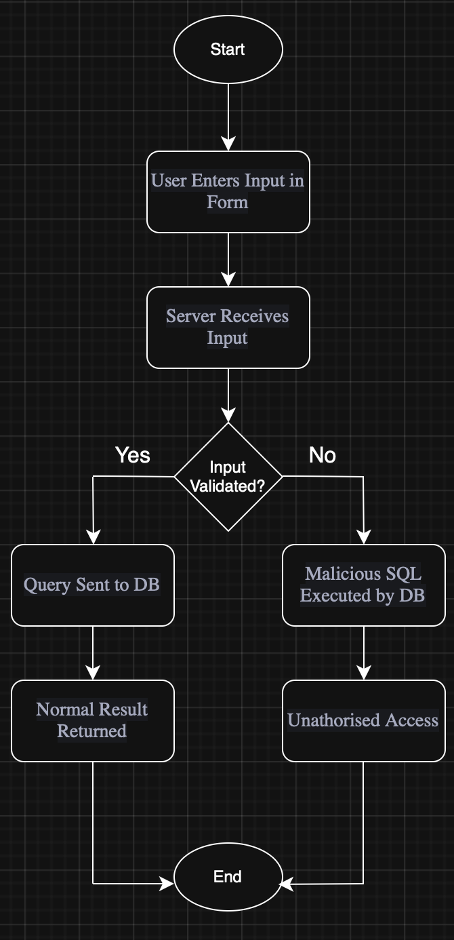
To present the design of proposed software more completely, I would use:
- Use Case Diagram: to identify actors and security-relevant interactions (e.g., login, search, admin functions).
- Sequence Diagram: to model the request lifecycle (input, validation, query construction, DB call) and make injection points visible.
- Class Diagram: to show separation of concerns (e.g., controller, validation service, data access layer), supporting secure patterns like prepared statements.
- Activity Diagram (as used in this post): to communicate decision logic and control flow clearly, including secure vs insecure pathways.
Together, these UML models provide functional, behavioural, and structural views that help manage security risks as part of the development lifecycle.
References
OWASP (2021) OWASP Top 10: The Ten Most Critical Web Application Security Risks. Available from: https://owasp.org/www-project-top-ten/ [Accessed: 23 February 2026]

